Experimental Results--No.3

Total Time：120 min

1. Use Case Diagram

Time：6 min

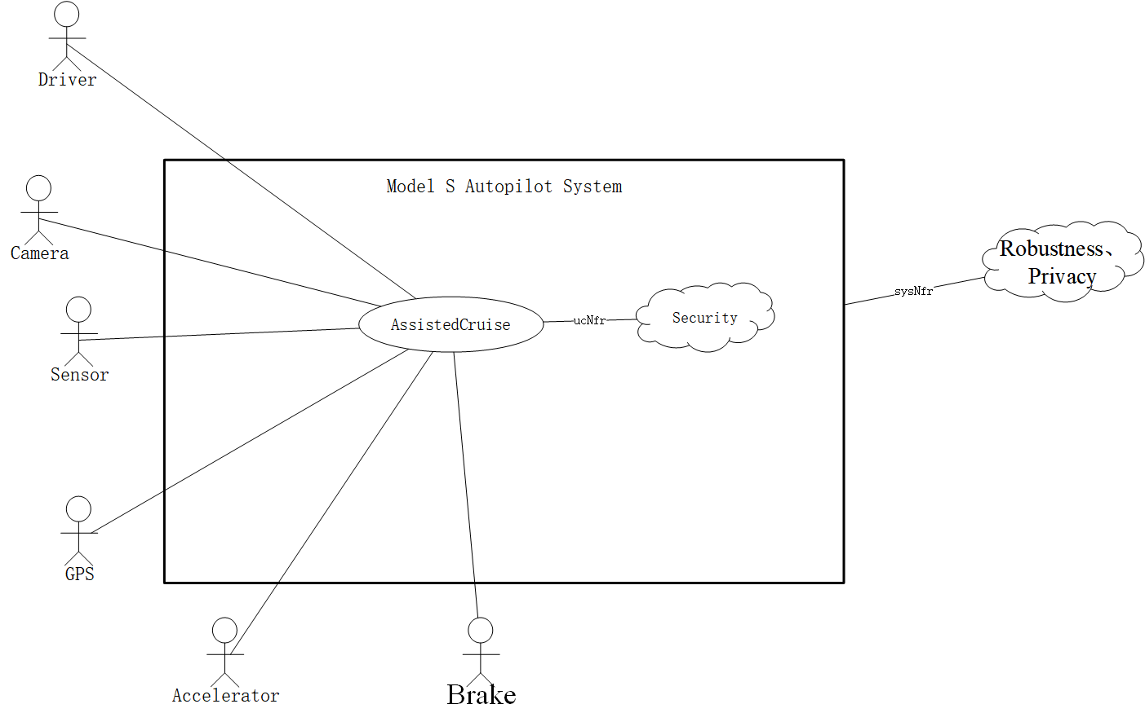

1. System Sequence Diagram

Time：75min

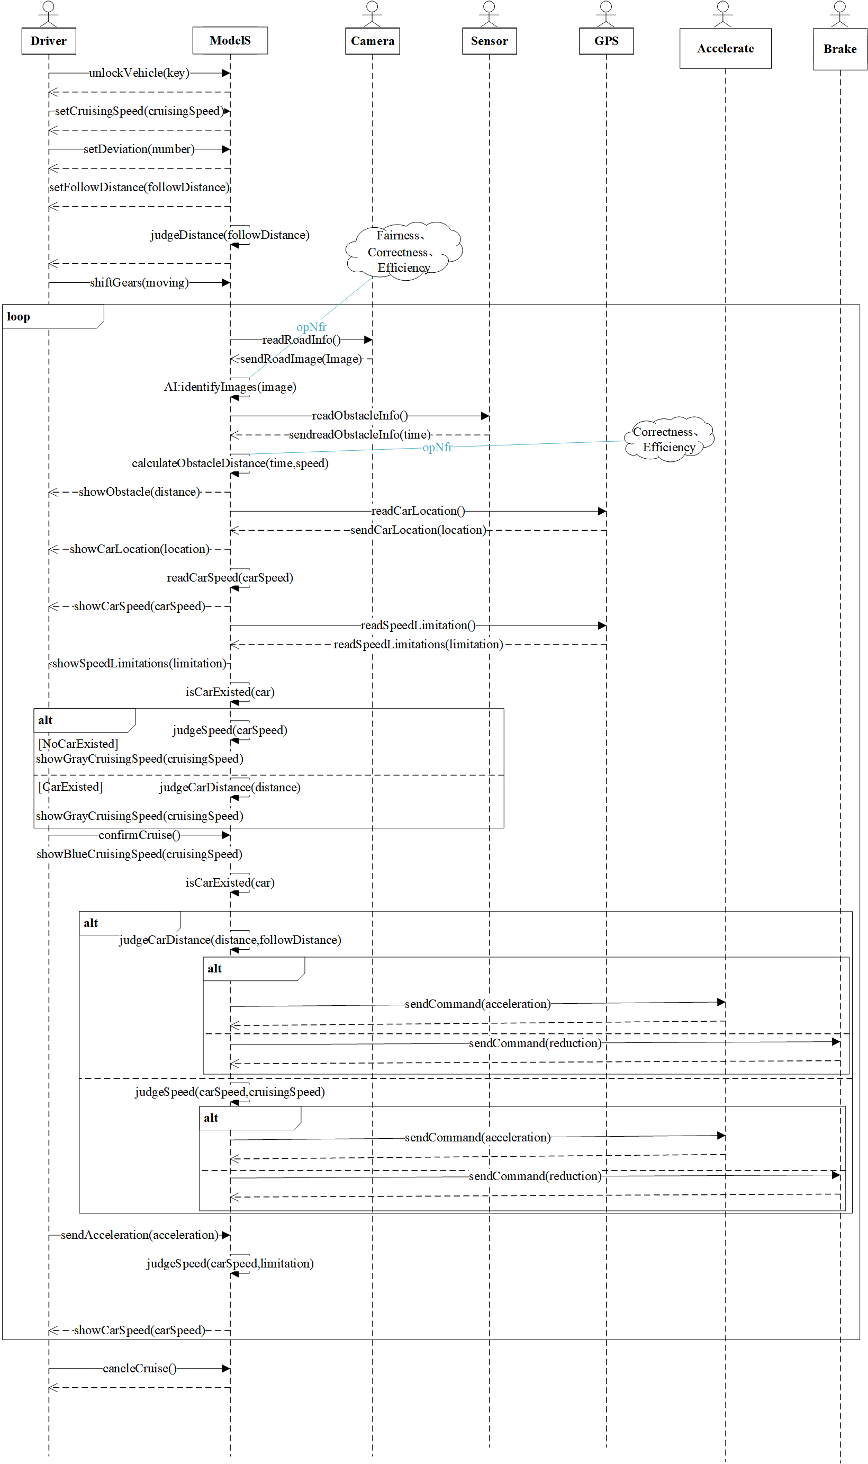

1. Conceptual Class Diagram

Time：17min

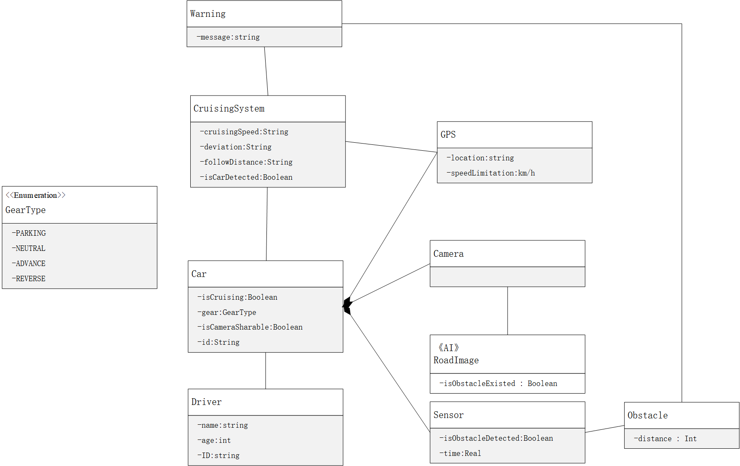

1. Context Diagram

Time：15min

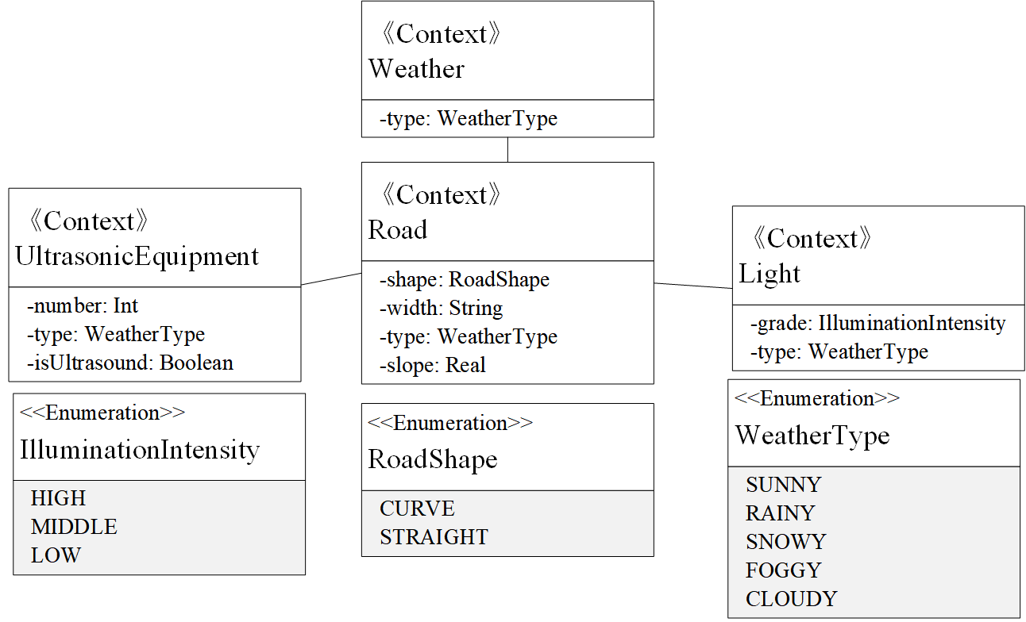

1. Machine Learning Diagram

Time：10min

